**7 Step guide to make Publication Ready Bargraphs from Scratch**

================

RwithAammar

12/11/2021

**# This guide will show you how to make publication ready barplots from scratch.**

**## Install these packages if you have not and load them:**

``` r

library(ggplot2)

library(ggthemes)

library(multcompView)

library(dplyr)

```

**## 1- Load or import your data**

We will use the following built-in dataset for this example:

``` r

data("chickwts")

tibble(chickwts) #tibble is a function of dplyr package

```

**## 2- Calculate *means* of you treatment groups and the *standard deviation* SD to show on error bars as follows:**

``` r

mean_data <- group_by(chickwts, feed) %>% #feed is our treatment in this example

summarise(weight_mean=mean(weight), sd = sd(weight)) %>% #to calculate mean and SD

arrange(desc(weight_mean)) #to arrange in descending order

tibble(mean_data)

```

**## 3- This step involves performing analysis of variance *ANOVA*, using buitin **aov()** function.**

Here we will draw *ANOVA* of weight against the group of treatment

(feed) in Chickwts data

``` r

anova <- aov(weight ~ feed, data = chickwts)

summary(anova)

```

**## 4- If the ANOVA is significantly different then, we will draw a multiple mean comparison test (TUKEY HSD, LSD, or Duncan Multiple Range) on *anova* object from previous step.**

*Here is an example of TUKEY HSD test* *Important Note:* You can also

use other tests and look for their commands by using ***agricolae***

package in this step.

``` r

tukey <- TukeyHSD(anova)

tukey

```

This will give us the significant differences based on each combination

of treatment groups from (feed). We can draw conclusion from this step

and write manually the significant difference. But *hold on* you can

also show these differences in bar plots in R.

**## 5- Draw multiple comparison letters using *multcomp* R package as follows:**

``` r

group_letters <- multcompLetters4(anova, tukey)

# we have to mention both anova model and tukey objects to get group letters

group_letters

```

As we have group letters now in step-5, we can extract these group

letters add them to our *mean_data* a data frame developed in step-2 as

follows:

``` r

#extracting group letters

group_letters <- as.data.frame.list(group_letters$feed)

#adding to the mean_data

mean_data$group_letters <- group_letters$Letters

tibble(mean_data)

```

\*Finally we have completed our statistical part, now we have to draw

the bar plot and show the significant difference on it.

**## 6- Drawing the *publication ready Barplot* in ggplot2**

``` r

p <- ggplot(mean_data, aes(x = feed, y = weight_mean)) +

geom_bar(stat = "identity", aes(fill = feed), show.legend = FALSE, width = 0.6) + #barplot

geom_errorbar( #this argument is putting sd as error bars

aes(ymin = weight_mean-sd, ymax=weight_mean+sd),

width = 0.1

) +

geom_text(aes(label = group_letters, y = weight_mean + sd), vjust=-0.4) + #add letters

scale_fill_brewer(palette = "BrBG", direction = 1) + #theme setting

labs(#this will add labels

x = "Feed Type",

y = "Chicken Weight (g)",

title = "Publication Ready Barplot",

subtitle = "Made by #RwithAammar",

fill = "Feed Type"

) +

ylim(0,410)+ #change your yaxis limits based on the letters

ggthemes::theme_par(); p

```

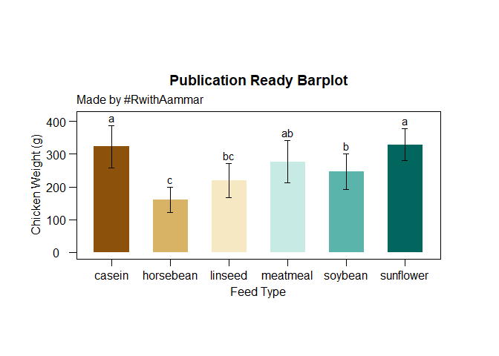

**## 7- Saving up to 4K barplots in R**

- First choose a working directory by pressing *ctrl+shift+H* and

select a folder then run the following code to save in **.tiff**:

``` r

tiff('Barplot.tiff', units="in", width=10, height=6, res=300, compression = 'lzw')

p

dev.off()

```